**SUPPLEMENTAL MATERIALS**

***Empathic and Numerate Giving: The Joint Effects of Images and Charity Evaluations***

**Example of Efficiency Manipulation**

**(From Study 4, conjoint evaluation)**

There are several international charities operating in Syria, and here you some find information about two of them, from an organization rating charities in terms of efficiency. Please review this information for a moment, before you move on to the next question.  
  
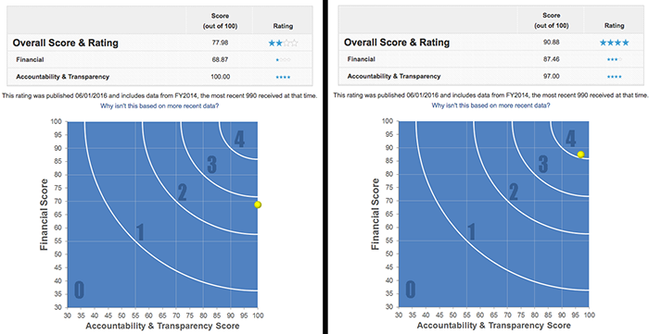

**Effectiveness manipulation, Study 5**

**(grey introductory text is the same as in the control condition)**

**What is polio?**

Poliomyelitis (polio) is a highly infectious disease caused by the polio virus. It invades the nervous system, and can cause paralysis or even death in a matter of hours.

**Who is at risk of catching polio?**

Polio mainly affects children under 5 years of age.

**What are the effects of polio?**

One in every 200 persons infected with polio leads to irreversible paralysis (usually in the legs). Among those paralysed, 5-10% die when their breathing muscles are immobilized by the virus.

**Is there a cure for polio?**

Once contracted there is no cure for polio. However, polio can be prevented by immunization. A safe and effective vaccine exists - the oral polio vaccine (OPV). Given multiple times, it protects a child for life. One dose of OPV can cost as little as 14 US cents.

**Why is so much focus placed on polio, but not on other diseases?**

Polio is one of only a few diseases which can be completely eradicated, such as was the case with smallpox. There are 3 strains of wild poliovirus, none of which can survive for long periods outside of the human body. If the virus cannot find an unvaccinated person to infect, it will die out. Polio eradication infrastructures are also used for the provision of other health services such as deworming tablets, vitamin A and bednets.  
  
**How far have we come in the process of eradicating polio?**  
In 1988, when the Global Polio Eradication Initiative was formed, polio paralysed more than 350,000 people a year. In 2013, only 416 polio cases reported. We are 99% of the way to eradicating polio globally. The world can be freed of the threat of polio - with everyone's commitment to overcome the last 1%.

**Is the quest to eradicate polio worth all the money invested in it?**

Yes, at least according to economists evaluating these efforts. The following is part of a summary from a scientific paper examining that very question:

"We estimate incremental net benefits of the GPEI [global polio eradication initiative] between 1988 and 2035 of approximately 40–50 billion dollars (2008 US dollars; 1988 net present values). […] The total economic costs saved per prevented paralytic poliomyelitis case drive the incremental net benefits […] This study finds a strong economic justification for the GPEI despite the rising costs of the initiative”.

**Control condition, Study 5**

**What is polio?**

Poliomyelitis (polio) is a highly infectious disease caused by the polio virus. It invades the nervous system, and can cause paralysis or even death in a matter of hours.

**Who is at risk of catching polio?**

Polio mainly affects children under 5 years of age.

**What are the effects of polio?**

One in every 200 persons infected with polio leads to irreversible paralysis (usually in the legs). Among those paralysed, 5%-10% die when their breathing muscles are immobilized by the virus.

**Is there a cure for polio?**

Once contracted there is no cure for polio.

**How does Polio spread?**

Polio is spread through person-to-person contact. When a child is infected with wild poliovirus, the virus enters the body through the mouth and multiplies in the intestine. It is then shed into the environment through the faeces where it can spread rapidly through a community, especially in situations of poor hygiene and sanitation.

Young children who are not yet toilet-trained are a ready source of transmission, regardless of their environment. Polio can be spread when food or drink is contaminated by faeces. There is also evidence that flies can passively transfer poliovirus from faeces to food.  
  
Even symptomless people carry the virus in their intestines and can “silently” spread the infection to thousands of others before the first case of polio paralysis emerges. For this reason, WHO considers a single confirmed case of polio paralysis to be evidence of an epidemic – particularly in countries where very few cases occur.

**What are the standards for detecting a circulation of poliovirus?**

Among other things, all acute flaccid paralysis (AFP) cases under 15 years of age or with paralytic illness at an age where polio is suspected should be reported immediately and investigated within 48 hours, and two stool specimens should be collected 24-48 hours apart and within 14 days of the onset of paralysis.

**What can be done in terms of basic hygiene to avoid polio?**

Wash your hands often. If soap and water aren’t available, clean hands with hand sanitizer (containing at least 60% alcohol). Don’t touch your eyes, nose, or mouth. If you need to touch your face, make sure your hands are clean.

# **Effectiveness and Image manipulations, Study 6**

**Below we display the image treatment from Study 6, as well as the screen containing the Effectiveness Information treatment (along with the donation choice/commitment), followed by the donation amount slider). Further implementation and design details can be found on our OSF preregistration (**<https://osf.io/pjm5n/>, <https://osf.io/pjm5n/registrations>, and at [this link (reveal.js slides](https://daaronr.github.io/dualprocess/SPI_EA_impact.html#/essex-piggyback)).

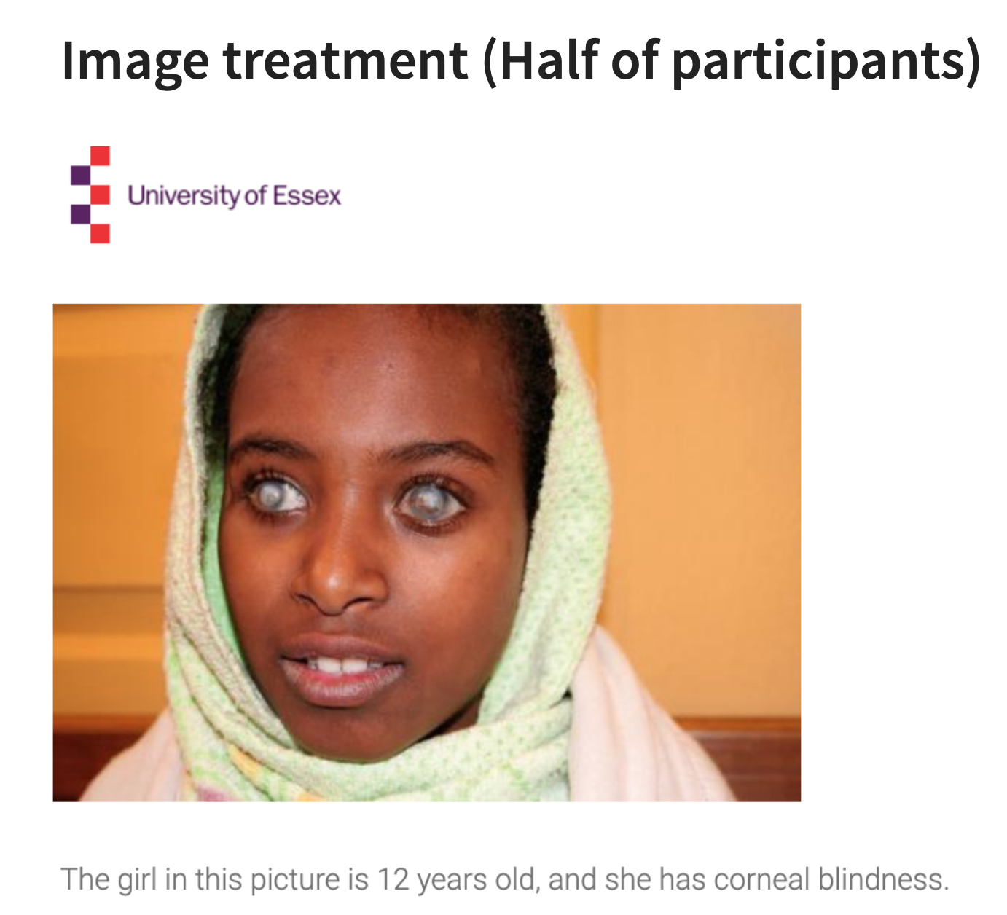

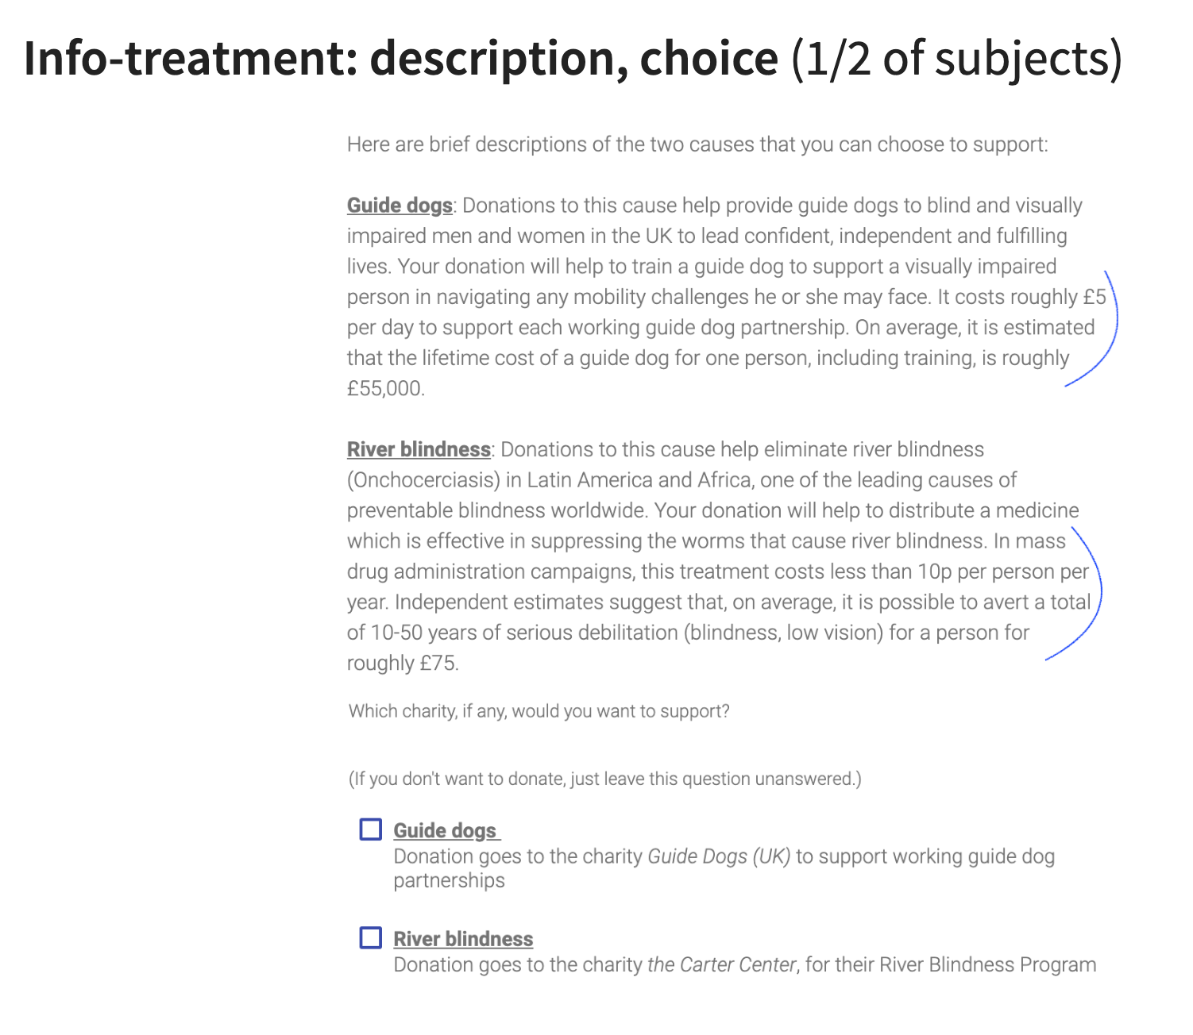

The Control screen was similar, but the last two sentences of each paragraph (indicated above in blue pen; starting with ‘It costs roughly £5 per day’ and with ‘In mass drug administration campaigns’) were not shown in the Control versions.

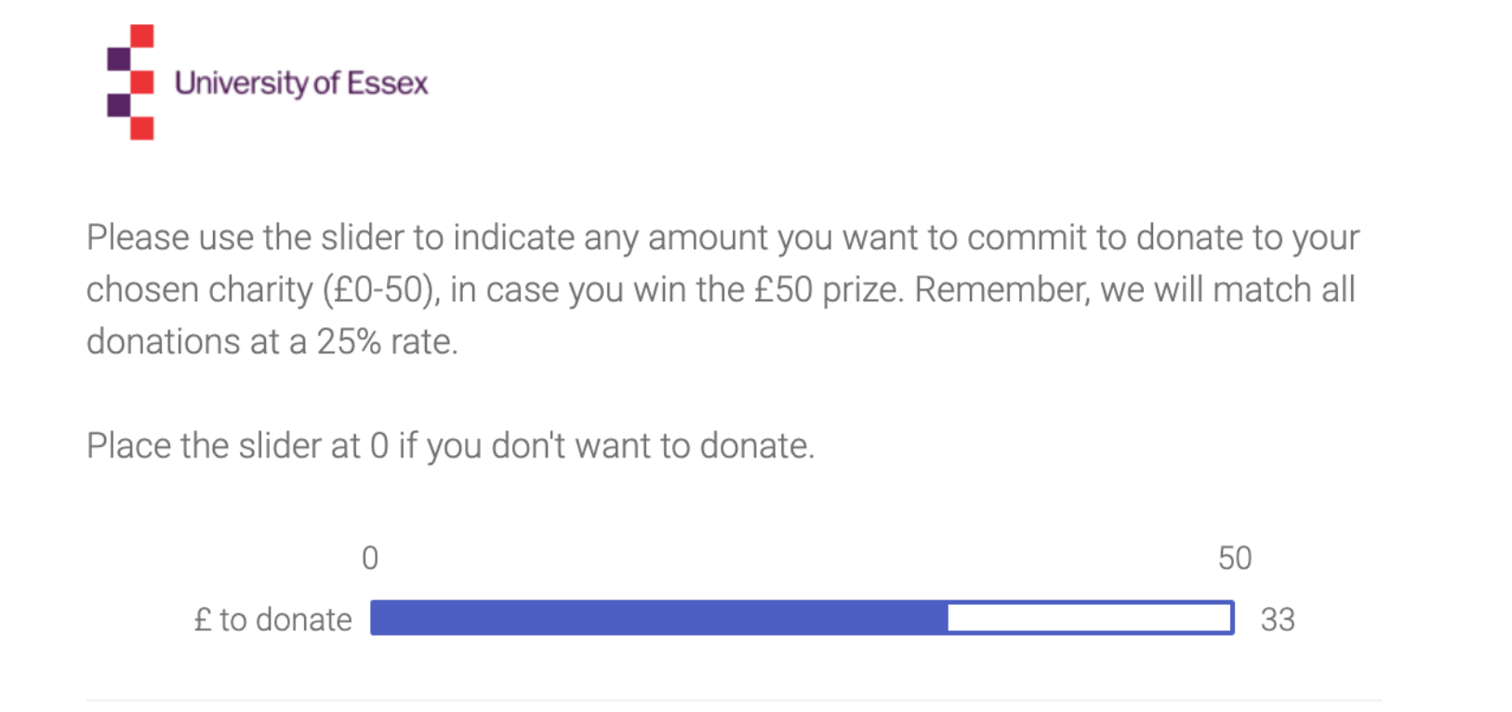

**Results including inattentive participants**

We also reran the analyses based on data from all participants who completed any of the measures in the study (i.e. including the participants who failed the attention checks).

**Study 1**

*Table S1a.* Two-part regression coefficients for experimental manipulations in Study 1 (*N* = 438).

|  |  |  |  |  |  |  |  |  |  |  |  |
| --- | --- | --- | --- | --- | --- | --- | --- | --- | --- | --- | --- |
| **Unstandardized results** | | | | | | | | | | | |
|  | **DONATE: NO (0) / YES (1)** | | |  | | | | **DONATED (NON-ZERO) AMOUNTS** | | | |
|  | ***B*** | **S.E.** | ***P*** | | |  | | | ***B*** | **S.E.** | ***p*** |
| EFF05 | -0.190 | 0.200 | 0.343 | | |  | | | 0.089 | 0.117 | 0.445 |
| IM05 | 0.406 | 0.200 | 0.042 | | |  | | | 0.203 | 0.117 | 0.082 |
| IMXEFF | -0.242 | 0.400 | 0.545 | | |  | | | -0.325 | 0.233 | 0.164 |
|  |  |  |  | | |  | | |  |  |  |
| **Standardized results** | | | | | | | | | | | |
|  | **DONATE: NO (0) / YES (1)** | | | |  | | **DONATED (NON-ZERO) AMOUNTS** | | | | |
|  | ***β*** | **S.E.** | ***P*** | | |  | | | ***β*** | **S.E.** | ***p*** |
| EFF05 | -0.052 | 0.055 | 0.342 | | |  | | | 0.046 | 0.060 | 0.445 |
| IM05 | 0.111 | 0.054 | 0.040 | | |  | | | 0.104 | 0.060 | 0.082 |
| IMXEFF | -0.033 | 0.055 | 0.544 | | |  | | | -0.083 | 0.060 | 0.163 |

*Note*. DONATE: NO (0) / YES (1) = Dichotomous two-part outcome (Donated: Yes/no), DONATED (NON-ZERO) AMOUNTS = Continuous two-part outcome (Non-zero donated amounts), EFF05 = Efficiency information manipulation (effect coded: +/-0.5), IM05 = Image manipulation (effect coded: +/-0.5), IMXEFF = Image × Efficiency information.

**Study 2**

*Table S2b.* Two-part regression coefficients for experimental manipulations in study 2 (*N* = 668).

|  |  |  |  |  |  |  |  |  |  |  |  |
| --- | --- | --- | --- | --- | --- | --- | --- | --- | --- | --- | --- |
| **Unstandardized results** | | | | | | | | | | | |
|  | **DONATE: NO (0) / YES (1)** | | |  | | | | **DONATED (NON-ZERO) AMOUNTS** | | | |
|  | ***B*** | **S.E.** | ***p*** | | |  | | | ***B*** | **S.E.** | ***p*** |
| EFF105 | -0.175 | 0.226 | 0.441 | | |  | | | 0.026 | 0.128 | 0.840 |
| EFF205 | -0.182 | 0.227 | 0.423 | | |  | | | 0.014 | 0.132 | 0.915 |
| IM05 | 0.129 | 0.161 | 0.423 | | |  | | | 0.118 | 0.090 | 0.189 |
| IMXEFF | 0.137 | 0.453 | 0.762 | | |  | | | -0.527 | 0.257 | 0.040 |
| IMXEFF2 | 0.095 | 0.454 | 0.835 | | |  | | | -0.306 | 0.263 | 0.245 |
|  |  |  |  | | |  | | |  |  |  |
|  |  |  |  | | |  | | |  |  |  |
| **Standardized results** | | | | | | | | | | | |
|  | **DONATE: NO (0) / YES (1)** | | | |  | | **DONATED (NON-ZERO) AMOUNTS** | | | | |
|  | ***β*** | **S.E.** | ***p*** | | |  | | | ***β*** | **S.E.** | ***p*** |
| EFF105 | -0.039 | 0.051 | 0.440 | | |  | | | 0.011 | 0.056 | 0.840 |
| EFF205 | -0.041 | 0.051 | 0.423 | | |  | | | 0.006 | 0.057 | 0.915 |
| IM05 | 0.035 | 0.044 | 0.423 | | |  | | | 0.063 | 0.048 | 0.189 |
| IMXEFF | 0.015 | 0.051 | 0.762 | | |  | | | -0.115 | 0.056 | 0.040 |
| IMXEFF2 | 0.011 | 0.051 | 0.835 | | |  | | | -0.067 | 0.057 | 0.245 |

*Note.* DONATE: NO (0) / YES (1) = Dichotomous two-part outcome (Donated: Yes/no), DONATED (NON-ZERO) AMOUNTS = Continuous two-part outcome (Non-zero donated amounts), EFF105 = Positive efficiency information manipulation (effect coded: +/-0.5), EFF205 = Negative efficiency information manipulation (effect coded: +/-0.5), IM05 = Imagery manipulation (effect coded: +/-0.5), IMXEFF = Imagery × Positive efficiency information, IMXEFF2 = Imagery × Negative efficiency information.

**Study 3**

*Table S3b.* Two-part regression coefficients for experimental manipulations in study 3 (*N* = 681).

|  |  |  |  |  |  |  |  |  |  |  |  |
| --- | --- | --- | --- | --- | --- | --- | --- | --- | --- | --- | --- |
| **Unstandardized results** | | | | | | | | | | | |
|  | **DONATE: NO (0) / YES (1)** | | |  | | | | **DONATED (NON-ZERO) AMOUNTS** | | | |
|  | ***B*** | **S.E.** | ***p*** | | |  | | | ***B*** | **S.E.** | ***p*** |
| EFF105 | -0.304 | 0.261 | 0.245 | | |  | | | 1.106 | 1.880 | 0.556 |
| EFF205 | -0.054 | 0.268 | 0.839 | | |  | | | -1.473 | 1.787 | 0.410 |
| IM05 | 0.207 | 0.190 | 0.276 | | |  | | | 2.837 | 1.295 | 0.028 |
| IMXEFF | -0.151 | 0.523 | 0.773 | | |  | | | -0.344 | 3.760 | 0.927 |
| IMXEFF2 | 0.488 | 0.535 | 0.362 | | |  | | | -0.557 | 3.575 | 0.876 |
|  |  |  |  | | |  | | |  |  |  |
|  |  |  |  | | |  | | |  |  |  |
| **Standardized results** | | | | | | | | | | | |
|  | **DONATE: NO (0) / YES (1)** | | | |  | | **DONATED (NON-ZERO) AMOUNTS** | | | | |
|  | ***β*** | **S.E.** | ***p*** | | |  | | | ***β*** | **S.E.** | ***p*** |
| EFF105 | -0.068 | 0.058 | 0.244 | | |  | | | 0.030 | 0.051 | 0.556 |
| EFF205 | -0.012 | 0.060 | 0.839 | | |  | | | -0.040 | 0.048 | 0.409 |
| IM05 | 0.057 | 0.052 | 0.274 | | |  | | | 0.094 | 0.043 | 0.028 |
| IMXEFF | -0.017 | 0.059 | 0.773 | | |  | | | -0.005 | 0.051 | 0.927 |
| IMXEFF2 | 0.055 | 0.060 | 0.361 | | |  | | | -0.008 | 0.048 | 0.876 |

*Note.* DONATE: NO (0) / YES (1) = Dichotomous two-part outcome (Donated: Yes/no), DONATED (NON-ZERO) AMOUNTS = Continuous two-part outcome (Non-zero donated amounts), EFF105 = Positive efficiency information manipulation (effect coded: +/-0.5), EFF205 = Negative efficiency information manipulation (effect coded: +/-0.5), IM05 = Imagery manipulation (effect coded: +/-0.5), IMXEFF = Imagery × Positive efficiency information, IMXEFF2 = Imagery × Negative efficiency information.

**Study 4**

*Table S4b.* Two-part regression coefficients for experimental manipulations in study 4 (*N* = 657).

|  |  |  |  |  |  |  |  |  |  |  |  |
| --- | --- | --- | --- | --- | --- | --- | --- | --- | --- | --- | --- |
| **Unstandardized results** | | | | | | | | | | | |
|  | **DONATE: NO (0) / YES (1)** | | |  | | | | **DONATED (NON-ZERO) AMOUNTS** | | | |
|  | ***B*** | **S.E.** | ***p*** | | |  | | | ***B*** | **S.E.** | ***p*** |
| EFFI05 | 0.182 | 0.277 | 0.512 | | |  | | | -2.435 | 1.742 | 0.162 |
| EFFA05 | -0.327 | 0.268 | 0.221 | | |  | | | -0.274 | 1.853 | 0.883 |
| IM05 | 0.234 | 0.193 | 0.225 | | |  | | | 4.383 | 1.276 | 0.001 |
| IMXEFFI | 0.706 | 0.554 | 0.203 | | |  | | | -5.431 | 3.484 | 0.119 |
| IMXEFFA | -0.464 | 0.535 | 0.386 | | |  | | | 0.819 | 3.707 | 0.825 |
|  |  |  |  | | |  | | |  |  |  |
| **Standardized results** | | | | | | | | | | | |
|  | **DONATE: NO (0) / YES (1)** | | | |  | | **DONATED (NON-ZERO) AMOUNTS** | | | | |
|  | ***β*** | **S.E.** | ***p*** | | |  | | | ***β*** | **S.E.** | ***p*** |
| EFFI05 | 0.041 | 0.062 | 0.511 | | |  | | | -0.068 | 0.049 | 0.162 |
| EFFA05 | -0.073 | 0.059 | 0.219 | | |  | | | -0.008 | 0.051 | 0.883 |
| IM05 | 0.064 | 0.053 | 0.223 | | |  | | | 0.149 | 0.043 | 0.001 |
| IMXEFFI | 0.079 | 0.062 | 0.201 | | |  | | | -0.076 | 0.049 | 0.119 |
| IMXEFFA | -0.052 | 0.060 | 0.385 | | |  | | | 0.011 | 0.051 | 0.825 |

*Note.* DONATE: NO (0) / YES (1) = Dichotomous two-part outcome (Donated: Yes/no), DONATED (NON-ZERO) AMOUNTS = Continuous two-part outcome (Non-zero donated amounts), EFFI05 = Early efficiency comparison (effect coded: +/-0.5), EFFA05 = Late efficiency comparison (effect coded: +/-0.5), IM05 = Imagery manipulation (effect coded: +/-0.5), IMXEFFA = Imagery × Late efficiency comparison, IMXEFFI = Imagery × Early efficiency comparison

**Study 5**

*Table S7b.* Two-part regression coefficients for experimental manipulations in Study 5 (*N* = 455).

|  |  |  |  |  |  |  |  |  |  |  |  |
| --- | --- | --- | --- | --- | --- | --- | --- | --- | --- | --- | --- |
| **Unstandardized results** | | | | | | | | | | | |
|  | **DONATE: NO (0) / YES (1)** | | |  | | | | **DONATED (NON-ZERO) AMOUNTS** | | | |
|  | ***B*** | **S.E.** | ***p*** | | |  | | | ***B*** | **S.E.** | ***p*** |
| EFF05 | -0.010 | 0.191 | 0.959 | | |  | | | 0.116 | 0.196 | 0.552 |
| IM05 | 0.515 | 0.191 | 0.007 | | |  | | | 0.077 | 0.196 | 0.693 |
| IMXEFF | 0.339 | 0.381 | 0.373 | | |  | | | -0.540 | 0.391 | 0.167 |
|  |  |  |  | | |  | | |  |  |  |
| **Standardized results** | | | | | | | | | | | |
|  | **DONATE: NO (0) / YES (1)** | | | |  | | **DONATED (NON-ZERO) AMOUNTS** | | | | |
|  | ***β*** | **S.E.** | ***p*** | | |  | | | ***β*** | **S.E.** | ***p*** |
| EFF05 | -0.003 | 0.052 | 0.959 | | |  | | | 0.037 | 0.062 | 0.551 |
| IM05 | 0.140 | 0.051 | 0.006 | | |  | | | 0.025 | 0.063 | 0.692 |
| IMXEFF | 0.046 | 0.052 | 0.373 | | |  | | | -0.086 | 0.062 | 0.166 |

*Note*. DONATE: NO (0) / YES (1) = Dichotomous two-part outcome (Donated: Yes/no), DONATED (NON-ZERO) AMOUNTS = Continuous two-part outcome (Non-zero donated amounts), EFF05 = Efficiency information manipulation (effect coded: +/-0.5), IM05 = Imagery manipulation (effect coded: +/-0.5), IMXEFF = Imagery × Efficiency information.

# Donation rates by study

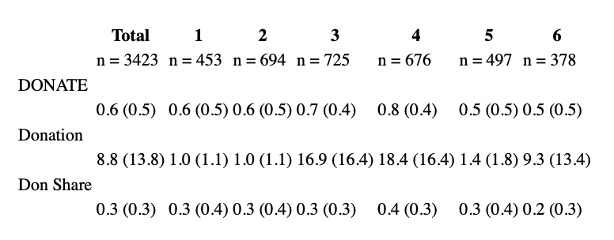

*Note*. Table reports means and standard deviations for each variable. DONATE: NO (0) / YES (1) = Dichotomous two-part outcome (Donated: Yes/no), Donation: Amounts including zeroes (in $ or £), Don Share: Share of maximum amount ($3, $3, $50, $50, $5, £50, respectively) donated

# Conditional-on-positive Treatment effects: Lee (2009) bounded estimates

As Lee (2009) explains,

* if treatments have an impact on selection into a particular *selection group*,
* and the composition of those selected into this *group* differs by treatment according to some *outcome*,
* then estimates comparing the *outcome* for treatment and control participants who are in this *selection group* will be biased.

More specifically, if we compare the mean donation for treatment and control participants *throwing out all those who did not donate…*

* this naïve ‘conditional-on-positive’ estimate is potentially biased,
* because, if the treatment

The “Lee-bound” procedure can recover *the impact of the treatment on the outcome, for those who would have been in the relevant ‘selected’ group whether or not they received the treatment*

* under a ‘monotonicity condition:
  + essentially, the treatment must make it either *more* or *less* likely that individuals select into the group (make a positive donation),
  + but it must not be that the treatment induces *some* individuals to select in (donate) who would not have otherwise done so, and *other* individuals to select out (not donate) who would have otherwise selected in.

Given this, the observed donors in the treatment (control) that induces a *greater likelihood of donation* would also have donated in the other treatment, but not vice-versa. To recover an asymptotically unbiased estimate of the impact of the treatment on “those who would always have donated”, an “apples to apples” comparison,

…we would need to “throw out” the participants in this treatment group who would not have donated under the other treatment.

Although we do not know who these “donate only in one treatment” people are, the bias will be greatest if these are the *largest* or *smallest donors.* This motivates the Lee-bound trimming procedure.

The procedure amounts to “…amounts to first identifying the excess number of individuals who were induced to be selected … because of the treatment and then trimming the upper and lower tails of the outcome… distribution by this number, yielding a worst-case scenario bound.” Bounds can be further tightened by doing the above *within* groups (identified by a baseline characteristic – in our case we use the study number and the alternate treatment arm, yielding 12 cells) and taking a weighted average of these. We can tighten these further as bounds on the *average treatment effect* (those reported in bold below); the details of this are rather technical.

We report the results below for the pooled data (meta-analysis) across six studies, focusing on the amounts donated share of the maximum possible amount one could donate, and reporting results for each treatment separately.

Lee Bounds on impact of *Image* treatment on “share of maximum possible amount donated” for those who would donate a positive amount with or without the *Image* treatment

Tightened Lee (2009) treatment effect bounds

Number of obs. = 3322

Number of selected obs. = 2209

Number of cells = 12

Overall trimming proportion = 0.0786

**Effect 95% conf. interval : [-0.0172 0.1192]**

------------------------------------------------------------------------------

| Observed Bootstrap Normal-based

don_share_ | Coef. Std. Err. z P>|z| [95% Conf. Interval]

-------------+----------------------------------------------------------------

im05 |

lower | .0131366 .0184498 0.71 0.476 -.0230244 .0492975

upper | .0886843 .018538 4.78 0.000 .0523505 .125018

Lee Bounds on impact of *Effectiveness Information* treatment on “share of maximum possible amount donated” for those who would donate a positive amount with or without the *Effectiveness Information* treatment

Tightened Lee (2009) treatment effect bounds

Number of obs. = 2872

Number of selected obs. = 1896

Number of cells = 12

Overall trimming porportion = 0.0146

**Effect 95% conf. interval : [-0.0652 0.0423]**

------------------------------------------------------------------------------

| Observed Bootstrap Normal-based

don_share_~y | Coef. Std. Err. z P>|z| [95% Conf. Interval]

-------------+----------------------------------------------------------------

eff05 |

lower | -.034899 .0184408 -1.89 0.058 -.0710422 .0012442

upper | .0123167 .0182411 0.68 0.500 -.0234352 .0480687

------------------------------------------------------------------------------

The 95% confidence bounds on the CoP treatment effect of the Image include a small (-1.7%) negative and a moderate positive (11.9%) effect.

The 95% confidence bounds on the CoP treatment effect of the *Effectiveness Information* include a moderate (-5.7%) negative and a moderate positive (4.2%) effect; loosely speaking we can statistically rule out that this treatment had a large CoP effect in either direction.

Although we cannot incorporate interaction effects in this bounding estimator in a straightforward way, we present below a similar estimate of the *impact of the Effectiveness treatment in the presence of the Image treatment*, i.e., only for the set of observations where the Image treatment is present.

Number of obs. = 1432

Number of selected obs. = 985

Number of cells = 6

Overall trimming porportion = 0.0044

**Effect 95% conf. interval : [-0.1012 0.0062]**

------------------------------------------------------------------------------

| Observed Bootstrap Normal-based

don_share_~y | Coef. Std. Err. z P>|z| [95% Conf. Interval]

-------------+----------------------------------------------------------------

eff05 |

lower | -.0626289 .0230794 -2.71 0.007 -.1078637 -.017394

upper | -.0348458 .0245779 -1.42 0.156 -.0830176 .0133259

------------------------------------------------------------------------------

Note that the 95% confidence interval for this effect includes a fairly large (10%) negative effect and only a very small positive effect (0.6%).

# Pooled-data regressions (meta-analysis); includes all participants

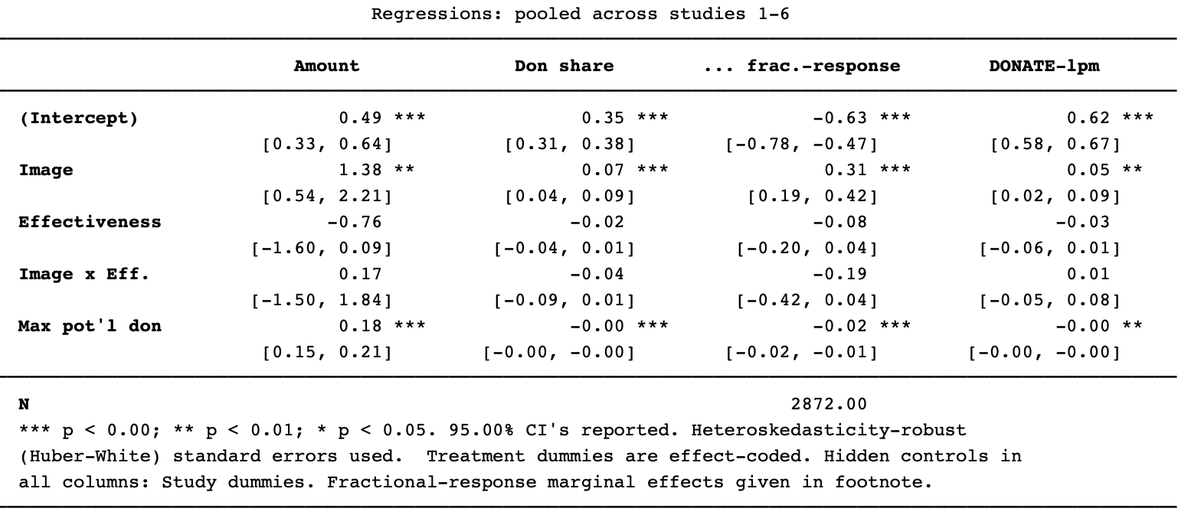

Column 1 gives an OLS regression of amount donated (including zeroes), including ‘inattentive’ participants. Columns 2-3 regress on the Share of maximum potential donation (“Max pot’l don”: $3, $3, $50, $50, $5, £50, for studies 1-6 respectively) donated. Column 2 is OLS, and column 3 is Papke-Wooldridge’s (2011) fractional response model.[1],[2] The final column presents a linear probability model of the binary “donated a positive amount” variable.

# Study 6: Impact on donations to each charity (all participants)

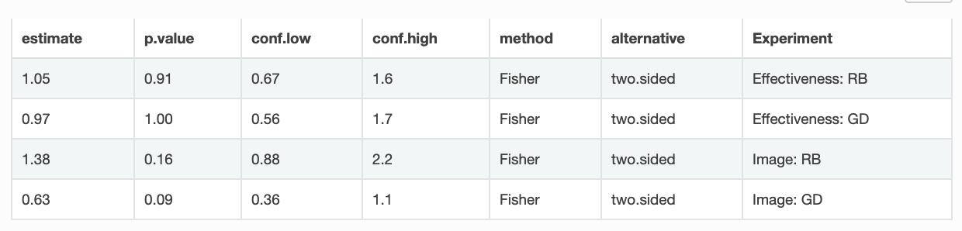

Above we see estimated of odds ratios, relative to the control group, of the incidence of donating to RB (Carter Center: the river-blindness charity) and GD (Guide Dogs for the blind). Confidence intervals reveal a lack of power. However, there is suggestive evidence (p=0.09 and p=0.16, respectively) that the image lead people to be less-likely to donate to GD and more likely to donate to RB. This may have been driven by the African appearance of the blind girl depicted.

As suggested by the box-plot below (means in red), there is also some evidence that the image treatment led to a lower *average* donation to GD (including zeroes). There is a (marginally) significant difference between the control and the Image treatment in a t-test (p=0.035) nd rank-sum test, p=0.059). (As always, all tests are two-tailed.)

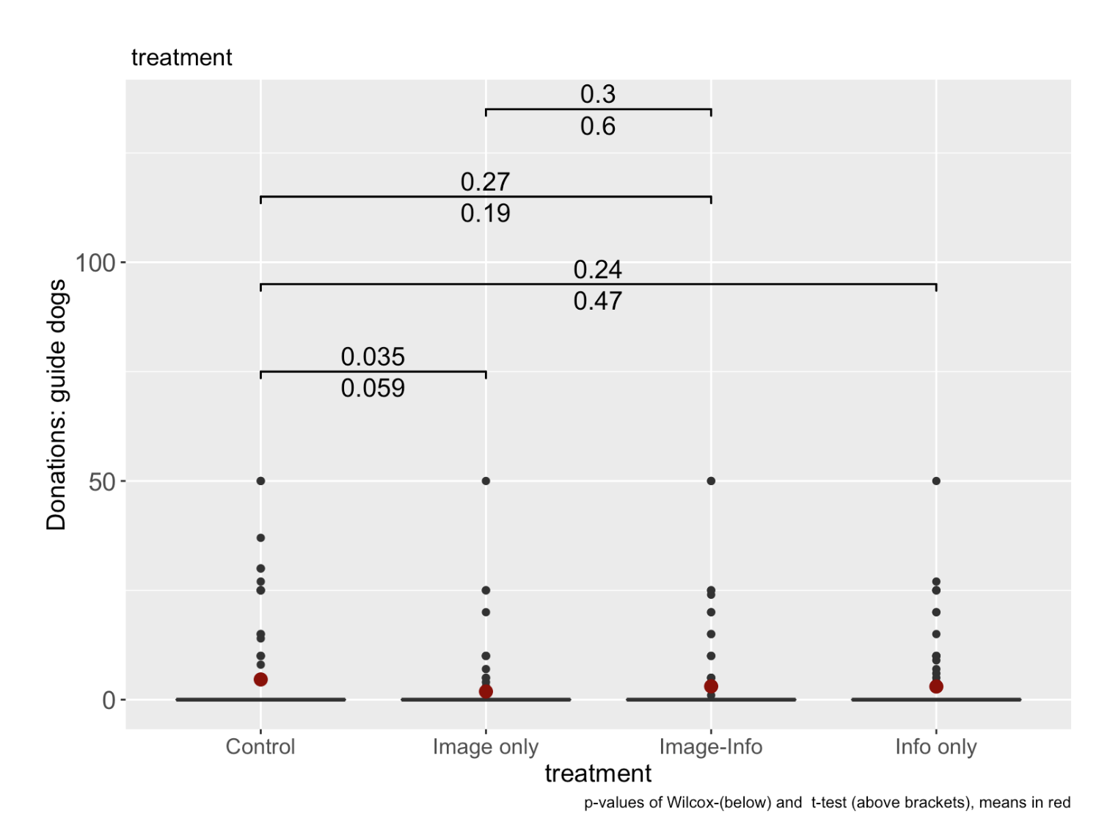

# Study 6: donation distributions (all participants)

As seen below, the distribution of donations was roughly similar across treatments.

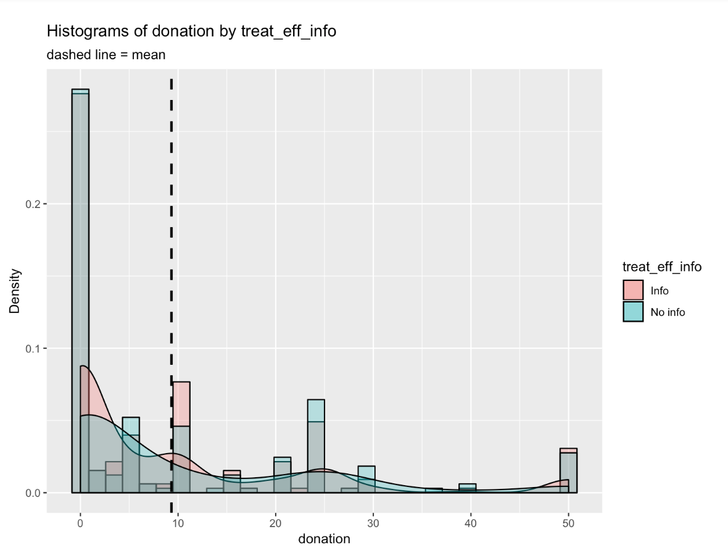

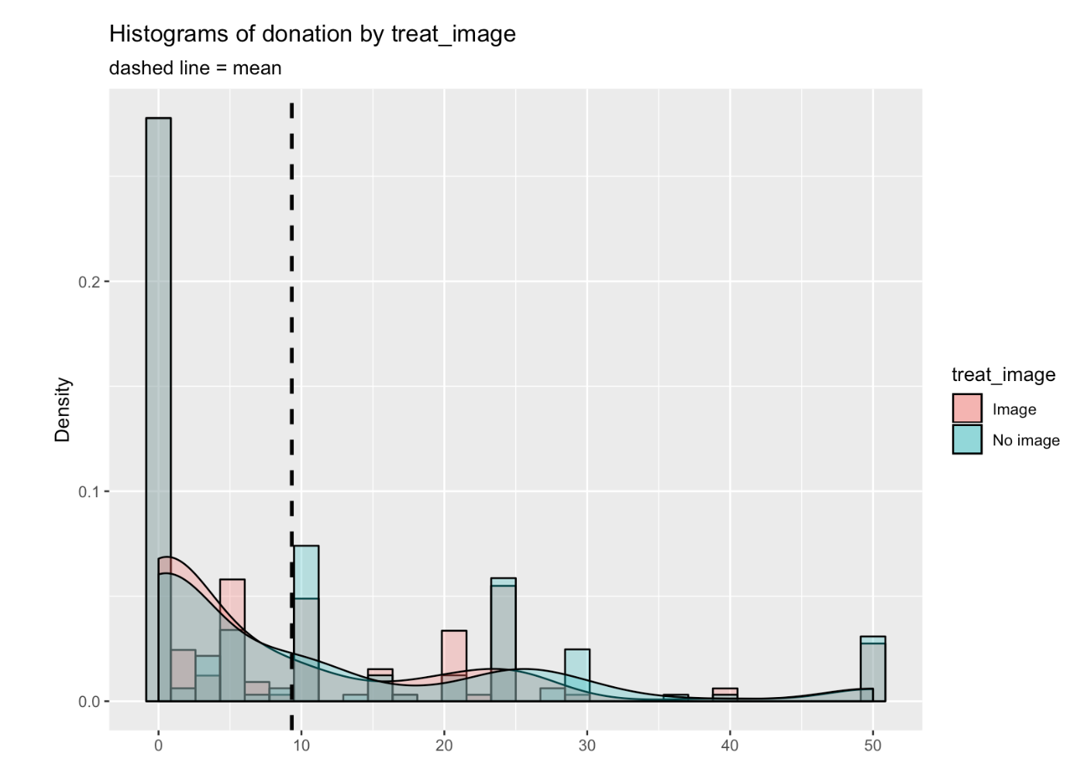

1. “Econometric Methods for Fractional Response Variables with an Application to 401 (K) Plan Participation Rates” Leslie E. Papke and Jeffrey M. Wooldridge, Journal of Applied Econometrics, Vol. 11, No. 6 (Nov. - Dec., 1996), pp. 619-632.
2. Fractional response average marginal effects: Image: 0.33, Effectiveness:, -0.08.

   0.3277 -0.07615 -0.01727 0.0296 0.9289 0.9952 -0.1844 0